**2. Table of Contents**

Document purpose…………………………………… 3

Testing section…………………………………………. 4

Checklists……………………………………………….. 5

Bugs……………………………………………………… 6

Test Cases………………………………………………. 7

Improvements…………………………………………. 8

Test Design Tehniques………………………………... 9

Summary……………………………………………….. 10



**3. Document Purpose**

Our goal is to ensure that the website being developed is high quality and meets costumers requirements.

We will be demonstrating our knowledge and skills in manual testing by testing a webpage and documenting our findings.

The purpose of this project is to develope and execute comprehensive testing for a webpage. The goal is to ensure that webpage is high quality, functions as expected and provides execellent user experience.

**4. Testing Section**

We are focusing on the product sections with cart, login and website general usability.

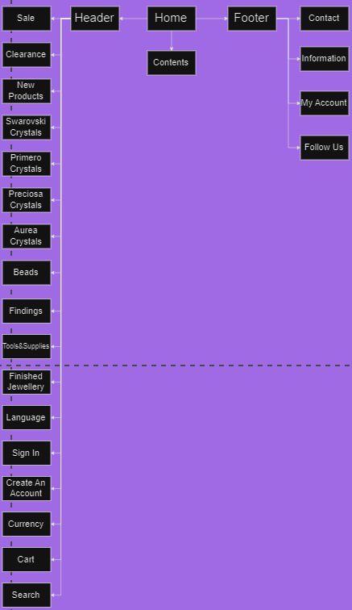

**5. Checklists**

**Login checklist**

1. Check if the login page load correctly
2. Check if the email and password fields are required and validated
3. Check if the „Forgot password“ link is functional and directs to „Reset your password“ page
4. Check if the „Login“ button works correctly and logs the user in
5. Check if the „Show Password“ works correctly and showing the password
6. Check if the the users „My Account“ page information is visible and correct after loging in
7. Check if the error handling by entering incorrect credentials and verifying that the error message is displayed.

**Cart Checklist**

1. Verify that the user is able to select and add items to their cart
2. Test adding multiple items to the cart
3. Verify correct display of selected items in the users cart
4. Test accurate cart total calculation for selected items and their quantities
5. Verify that the user is able to review their cart and update the quantities.
6. Test removing item from the cart

**Usability/General**

1. Check if the cookies consent notice is displayed to the user

2. Check if the company logo and name are visible

3. Check the correct placement of the website logo

4. Validate that the company logo is linked with the home page

5. Check the proper positioning and ease of usage of the search button

6. Check if the website structure is understandable and easy to use

7. Check if all text and images are aligned and displayed properly

8. Check if the text fonts, sizes and colors are consistent at the main page

9. Check if the buttons format and size are consistent at the main page

10. Check if the About the company

1. **Bugs**

We found from website www.crystals.ee one bug. [www.crystals.ee](http://www.crystals.ee) is the same page as [www.mycrystalidea.com/](http://www.mycrystalidea.com/) but this is in estonian language as this was a real life bug we found before the final project. In the screenshot you can see actual login process. Input „E-post“ is an e-mail field. Nex field below is „Salasõna“ which is a password input. In screenshot you can clearly see the "Show Password" (Näita salasõna) box is checked but it shows password as dots.

Another bug was found by Styven during the project

1. A purple bead on a white background

   Description automatically generated**A screenshot of a computer

   Description automatically generated Test Cases**

****

1. **Improvements**

* The stock balance of the product could be shown on product page
* The user could have the option to order an e-mail notification when the product is running low

**9.Test Design techniques**

In this project testing focuses mostly on the usability and functionality test design techniques. We focused more experience based tehniques like exploratory testing.   
In this final project we used checklist based teting, error guessing and exploratory testing.

1. **Summary**

For the SDA final project we chose the website https://www.mycrystalidea.com/

Using the knowledge and experience we gained during the 4 months of the software tester course we complite checklist and test cases to identify and report defects effectively

In summary, the final project was useful to show the knowledge acquired throughout the course

